
002
REVIEW STATUS
A - REVIEWED; WORK MAY PROCEED
B - REVIEWED WITH COMMENTS; REVISE & RESUBMIT;
WORK MAY PROCEED SUBJECT TO INCORPORATION OF
COMMENTS
C - OBJECTION - REVISE & RESUBMIT; WORK MAY
NOT PROCEED
D - REJECTED
E - REVIEW NOT REQUIRED; WORK MAY PROCEED
001
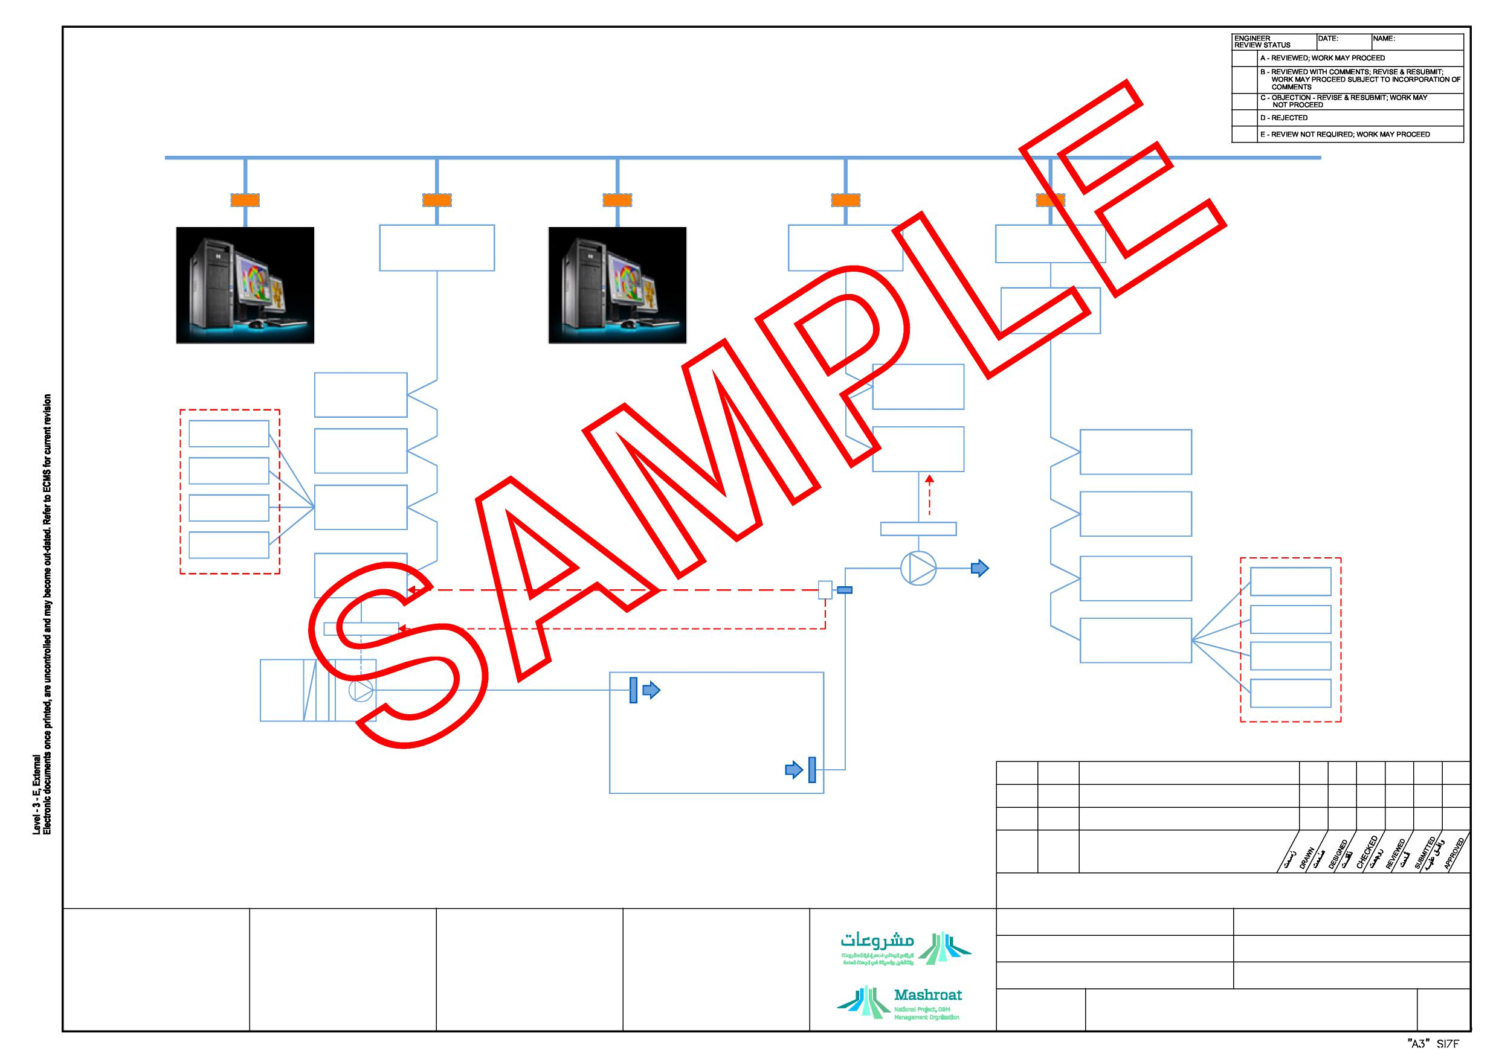
IT LAN-TCP/IP
ETHERNET
SWITCH/ROUTER (TYP.)
BACNet
BUILDING/NETWORK CONTROLLER
BACNet / LON OR MODBUS GATEWAY
BACNet
BUILDING/NETWORK CONTROLLER
CONNECTION
LON OR MODBUS
BUILDING /NETWORK
CONTROLLER
BMS WORKSTATION/SERVER MANAGEMENT LEVEL
MS/TP - DAISY CHAIN
MS/TP - DAISY CHAIN CONNECTION
BMS WORKSTATION OPERATION LEVEL (LIMITED FUNCTIONALITY)
BACNet ADVANCE
APPLICATION
CONTROLLER
BACNet ADVANCE
APPLICATION
CONTROLLER
UP TO 31 Nos
MS/TP - DAISY CHAIN CONNECTION
LIGHTING
AHU
FCU
BACNet ADVANCE
APPLICATION
CONTROLLER
BACNet ADVANCE
APPLICATION
CONTROLLER
LON OR MODBUS
ADVANCE APPLICATION
CONTROLLER
UP TO 31 Nos
BACNet ADVANCE
APPLICATION
CONTROLLER
OPTION 3 : GLOBAL CONNECTION BETWEEN DDC VIA TCP/IP FOR BACNet COMPLIANCE CONTROLLERS
STARTER / VFD
LON OR MODBUS
ADVANCE APPLICATION
CONTROLLER
UP TO 31 Nos
NOTE: THREE(3) OPTION ARE INDICATED FOR THE INTER CONNECTION OF NEGATIVE SOLATON ROOM EXHAUST TO THE SUPPLY AHU THE AHU NEEDS TO TURN OFF IN ANY CASE THAT THE EXHAUST FAN TURNS OFF TO AVOID PRESSURIZING THE ROOM AND SPREADING THE DISEASE
VAV
FLOW SWITCH / DIFF.
SENSOR/ OR PRESS.
SENSOR
LON OR MODBUS
ADVANCE APPLICATION
CONTROLLER
LIGHTING
EQUIPMENT BACNet FIELD DEVICES
AND APPLICATION SPECIFIC
CONTROLLER (TYP. TO ALL ASC)
BACNet ADVANCE
APPLICATION
CONTROLLER
OPTION 2 : DIGITAL INPUT TO THE DDC
NEGATIVE ISOLATION EXHAUST FAN
UP TO 31 Nos
AHU
S ARTER / VFD
OPTION 1 : ELECTRO MECHANICAL NETWORK
LON OR MODBUS
ADVANCE APPLICATION
CONTROLLER
FCU
VAV
NEGATIVE ISOLATION ROOM AHU
NEGATIVE ISOLATION ROOM
EQUIPMENT LON OR MODBUS FIELD
DEVICES AND APPLICATION SPECIFIC
CONTROLLER (TYP. TO ALL ASC)
001
27/03/19 BORDER CHANGED AND ISSUED FOR USE
000
24/01/18 ISSUED FOR USE
REV. No
DATE
REASON FOR ISSUE
DRAWING STATUS
ISSUED FOR USE
KINGDOM OF SAUDI ARABIA ةیدوعسلا ةیبرعلا ةكلمملا
PROJECT REFERENCE -
STANDARD DRAWING
XXX
FACILITY No.
PROJECT TITLE 1
BMS AND MECHANICAL
ARABIC TITLE
ARABIC TITLE
INTEGRATION BLOCK
X
CONTRACT No.
PROJECT TITLE 2
DIAGRAM
PROJECT TITLE 3
SCALE
REV
DRAWING No.
SHEET 1 OF 1
EPM-KEE-13-000003
NTS

